**Affamato: Phase Three Report**

**Team**:

Canvas Group: **Falcon**

**Phase Three Team Lead:** Julia Rebello

**Members**:

* Cameron Clark: [cameron.clark0821@utexas.edu](mailto:cameron.clark0821@utexas.edu) \\ [github.com/cameronclark0821](https://github.com/cameronclark0821)
* Justin Henry: [justinhenry@utexas.edu](mailto:justinhenry@utexas.edu) \\ [github.com/justinhenry](https://github.com/justinhenry)
* Alex Issa: [alex.issa32@utexas.edu](mailto:alex.issa32@utexas.edu) \\ [github.com/alexissa32](https://github.com/alexissa32)
* Julia Rebello: [julialrebello@utexas.edu](mailto:julialrebello@utexas.edu) \\ [github.com/JLRebello](https://github.com/JLRebello)
* Samir Riad: [sriad123@utexas.edu](mailto:sriad123@utexas.edu) \\ [github.com/sriad123](https://github.com/sriad123)
* Rooshi Patidar: [rooshipatidar@utexas.edu](mailto:rooshipatidar@utexas.edu) \\ [github.com/rooshimadethis](https://github.com/rooshimadethis)

**URL** to Github/Gitlab repo and shared Google docs:

* Github: <https://github.com/alexissa32/Affamato>
* Google Drive: <https://drive.google.com/drive/folders/0ANUp-cLx6lnZUk9PVA>
* Slack: <https://team-falcon-group.slack.com>

**Website URL:** [https://www.affamato.xyz/](http://www.affamato.xyz/)

**Phase III Report Contents:**

1. Goals and Accomplishments
2. Design and Requirements
3. Scraping and Database (Description)
4. Scraping and Database (Screenshots)
5. Screens, Features and Functionality (Description)
6. Screens, Features and Functionality (Screenshots)
7. Tools, Software and Frameworks Used
8. Testing
9. Final Reflections

1. Goals and Accomplishments

Phase III - due April 29

* At least 5 more user stories –put them on your issue boards
* Scraping/DB:
  + Finish data collection- all recipes, food, and relevant info is scraped and stored in the database
  + Database also holds all Cooks (Users of the site) and their relevant information
* Backend:
  + Login page is fully functional but no account creation stored by Affamato (sign in with google -> new account creation would be like making a new google acct. Still holds their recipe list, grocery list, and inventory, etc.)
    - Login functionality works, and user can fully use inventory, recipe list, grocery lists via front end
    - All users have functional: grocery list, pantry, recipe list, etc.
  + Fully functional search implementation
* Frontend:
  + Add front end pages for search results, discover page
  + Finish functionality of recipes page, inventory page, and grocery list page
  + Further refinement of dynamic site with many pages hosted on GCP
    - Refined about page
    - Refined landing page
* Testing (Refine and expand):
  + Most Frontend/GUI tests using Selenium
  + Most Backend/Java+Servlet tests using JUnit
  + Visual inspection is also used in niche scenarios
* Add to and refine the technical report, updating as we go
  + Fix Phase 2 Errors in Class diagram+add sequence diagram

Comments:

* To see our user stories on issue boards, check our Github. To see them in the report, check the “Design and Requirements” section below.
* To see the other major bullet points and their progress, check the relevant sections titles below.
* Things we realized we didn’t need (That were initially listed in our Proposal):
  + Java Spring-Not necessary for a small-scale application
  + Elasticsearch-We built our own search functionality
  + SQL DB and querying-We used NoSQL/datastore and JSON to hold all information
  + Reactjs-Built our front end with JSPs/DHTML and bootstrap
  + Mocha-There’s no JS code to test
  + Postman-No APIs able to test (Most aren’t exposed/require a user to be logged in through Google)

2. Design and Requirements

Class Diagram:

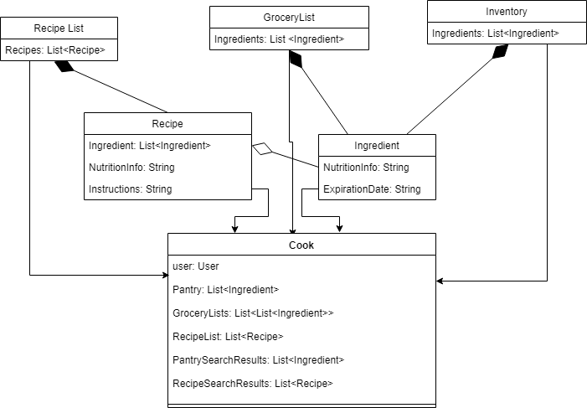

Note: The relationship between the other classes and the Cook class is a weak association because the Cook fields are made from some parts of ingredients and recipes but is not strictly made of those objects.

Sequence Diagram:

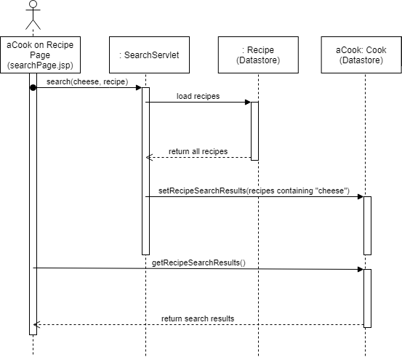

This sequence diagram depicts a user who is already logged in searching for recipes on the search page.

Phase I User Stories:

1. Save user’s money
   1. As a thrifty consumer, I would like to cut down on grocery shopping by efficiently using my groceries, so I am not re-purchasing items unnecessarily.
2. Reduce food waste
   1. As a green consumer, I would like to reduce the amount of food I waste by tracking when items expire so that I may use all of the perishables that I purchase.
3. Calorie counter: lose weight, focusing on calories
   1. As someone who would like to lead a healthier lifestyle, I would like to have quick access to the nutritional information of the food I buy.
4. Tries new recipes (For example, wanting cuisine type X)
   1. As an adventurous foodie, I would like to try new recipes.
5. Bulking: gain weight, focusing on maximizing volume of protein and healthy fats, getting more with less so one can fit it in the fridge/only need to get groceries once a week.
   1. As a bodybuilder, I would like to increase my muscle mass by consuming

the right foods at a great enough volume.

6. Trying to follow a specific diet for health-related reasons

* 1. As a someone who has dietary and health restrictions, I would like to have easy access to what foods I can eat, and what recipes I can make with them.

7. User who wants to obtain cooking skills

1. As a someone who has just left home, I would like to become more independent by learning some easy recipes I can make for myself.

8. User who wants to purchase cheap items and find recipes for them

1. As a someone who likes to purchase on-sale items and use coupons to shop cheaply, I would like to find recipes that will accomodate my purchases.

9. Vegetarian User

1. As a someone who has chosen to be a vegetarian for personal reasons, I would like to find recipes I can make with ingredients that don’t include any meats, poultry, or fish.

10. Advanced cooking-level/chef user who wants to improve skills

1. As a chef or someone who cooks very often and already have skills in the kitchen, i’d like to improve and advance my skills even further by exploring recipes that include unfamiliar ingredients.

11. Parent User

1. As a parent or guardian of young children, I would like to find recipes that use kid-friendly ingredients so that I can cook healthy meals my children will want to eat.

12. Coupon Collecting User

1. As someone who saves money by using coupons, I’d like to purchase my items based on what coupons are available, and then discover new recipes to use these items.

13. Budget Tracking User

1. As someone who wants to track my food budget, I’d like to track how much food I buy, and how much of it I use before it perishes, and be able to maximize my budget, and learn the best food purchasing habits to keep my budget lean.

14. Caretaker User

1. As a caretaker, I’d like to be able to easily buy food items that fit within various dietary restrictions, and learn various recipes I can make with these items to make healthy and varying dishes.

15. Social Butterfly User

1. As a user whose social life is very important to them, I’d like to be able to manage several different grocery lists so that if I plan to throw an event, I can quickly see what I have at home and what I need to buy, as opposed to a grocery list that I have for normal daily runs to the grocery store.

16. Culture Exploring User

1. As a user who loves to travel, I would like to explore different cuisines by learning about new ingredients and recipes so that I may familiarize myself ahead of time before an international trip.

Phase III User Diagrams:

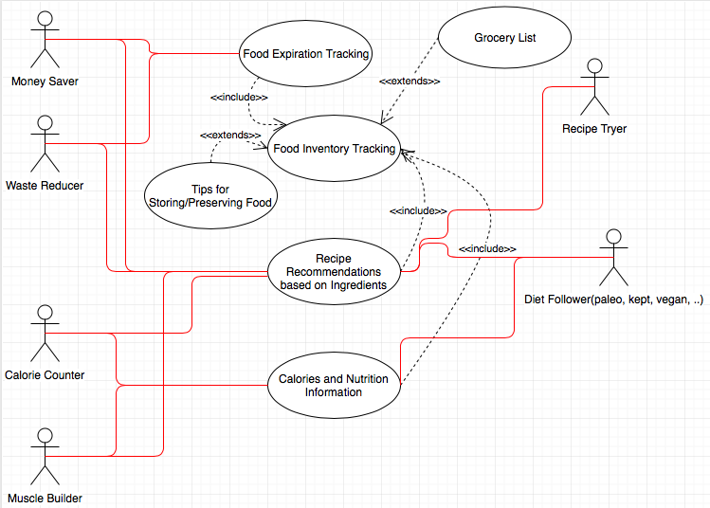

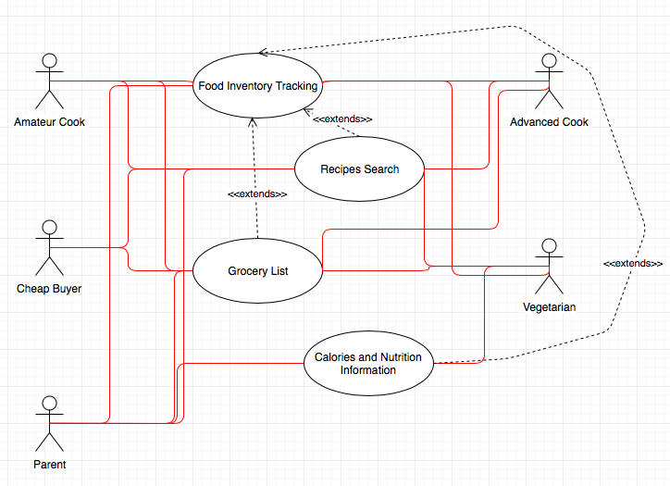

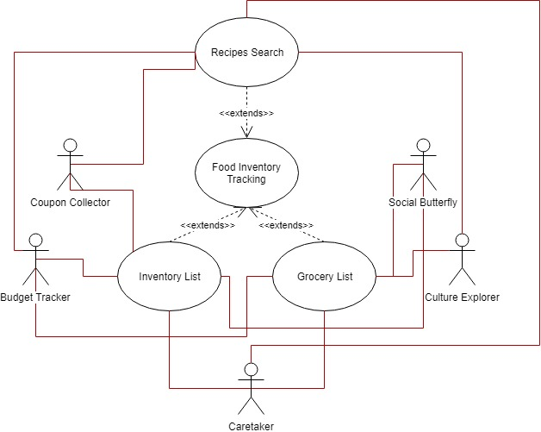

3. Scraping and Database (Description)

Recipes and Ingredients exist in our datastore to serve as a database to be searched. Both include fields with relevant information to use. For the Recipes, these include: strings for the recipe title and instructions, integers for the minutes to prepare and cook the recipe, and booleans for if the recipe is vegetarian, vegan, ketogenic, gluten free, and dairy free. For the Ingredients these include: a string for the ingredient name, along for the ingredient ID (provided by spoonacular), a float for the amount of the ingredient, and string for the units of that amount. We also included a string that includes information about the nutrients in the ingredient given a quantity of the ingredient. These fields are summarized in the following screenshots.

In phase three we implemented the Cook object in the datastore. Each cook represents one user who has logged in via Google. This object stores all of the relevant information for the user. The datastore does not allow storage of arrays or JSON objects, so the fields were implemented as string representations of JSON arrays. The fields in the cook class include all of the relevant information for the user. This includes: PantryList, a list of the ingredients the user has in their inventory; GroceryList, a list of the ingredients the user intends to buy at the store; and RecipeList, a list of Recipes the user has saved. We also have fields for search results for searches the user just made: RecipeSearchResults, GrocerySearchResults, and RecipeSearchResults. All of these fields are also summarized in the following screenshots. We update these fields whenever necessary, and we clear the search results data whenever a person leaves the page or searches for something new.

All of our code can be seen on the Github.

4. Scraping and Database (Screenshots)

-Extensive List of Ingredients in GCP Datastore:

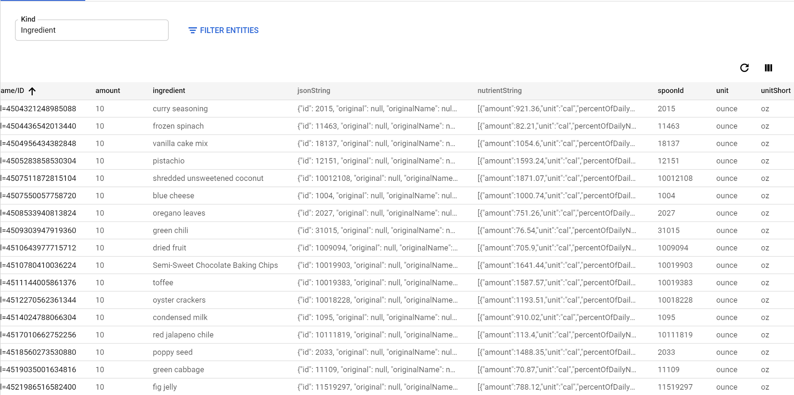

-Extensive List of Recipes in GCP Datastore

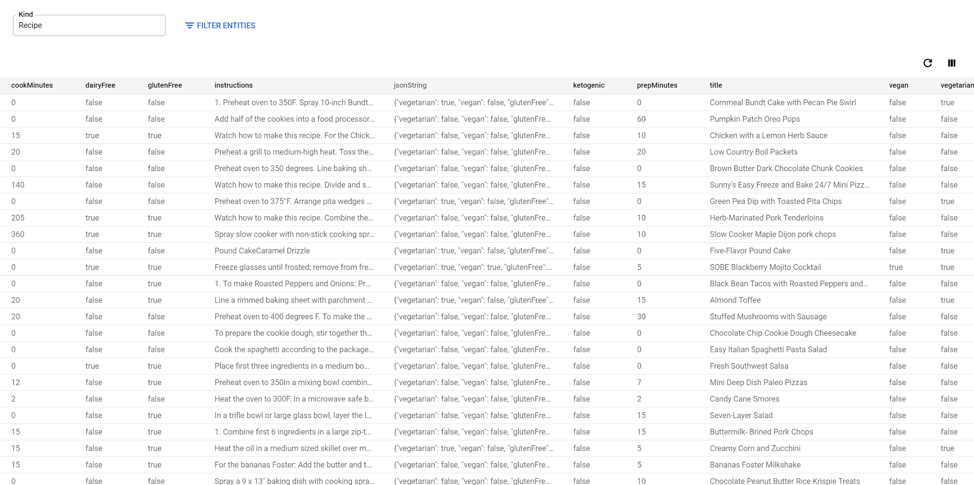

-Cook objects in the Datastore for users

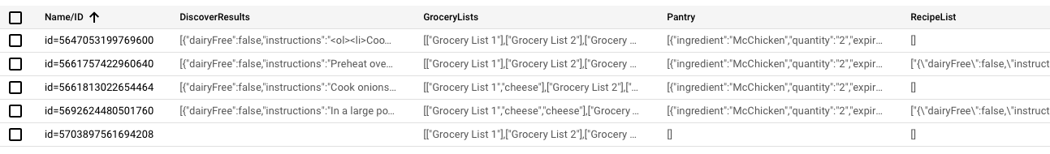

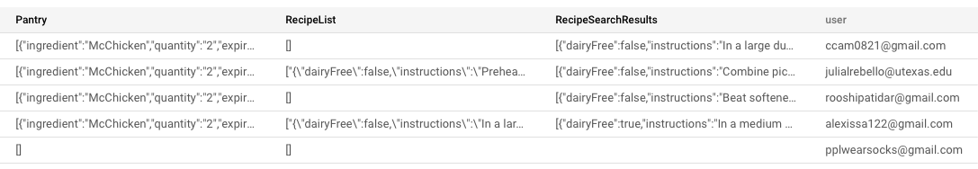

5. Screens, Features and Functionality (Description)

We have implemented a dynamic website (In DHTML). When the website is opened the welcome and about pages will be visible. When you log in with your gmail account, the dashboard page becomes available, and selections from the dashboard page which will display grocery list, food inventory, recipes list, and search recipes. Logging out will also become an option. The pages are somewhat functional; accounts are now implemented and users can search for recipes. Users can search for recipes and favorite/unfavorite them. Users can also save ingredients to their inventory and to their grocery lists manually.

All of our code can be seen on the Github.

6. Screens, Features and Functionality (Screenshots)

-Affamato Landing Page:

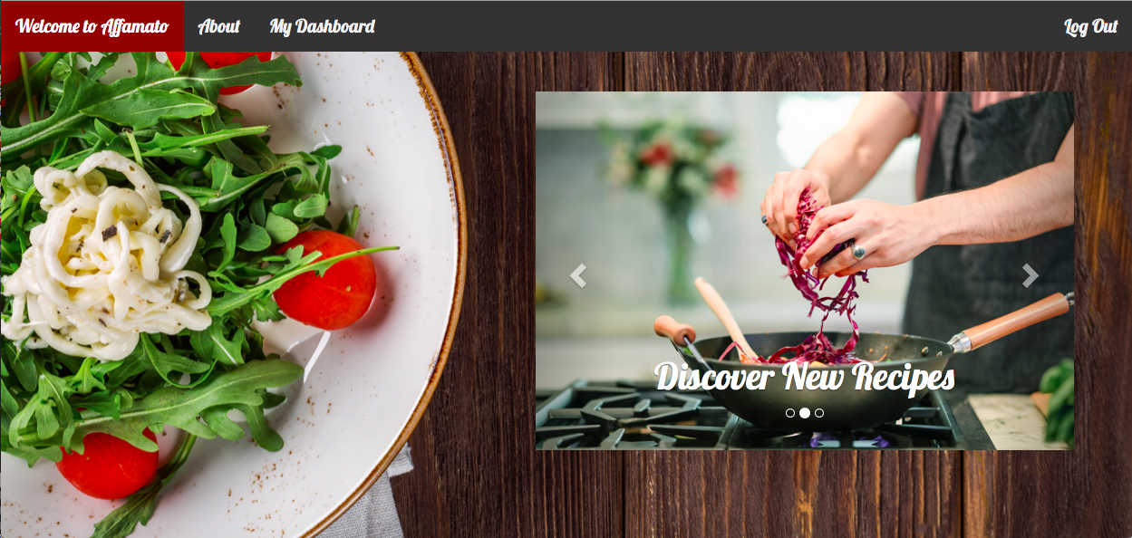

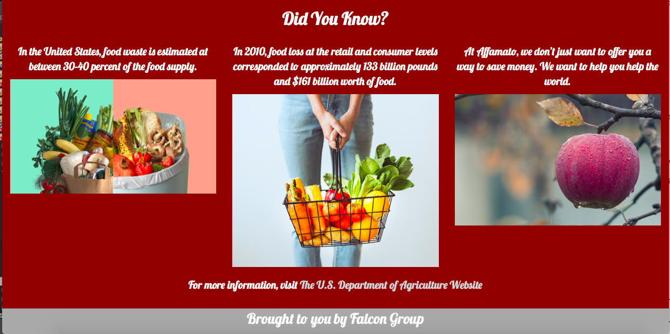

Affamato’s landing page is the first thing a user sees, and is meant to convey what Affamato provides for users, an option to log in with their google account, and a sort of call to action with the purpose of reducing food waste. The page also features a link to the U.S. Department of Agriculture website, in case the user would like to learn more about food waste in the United States.

-Affamato About Page

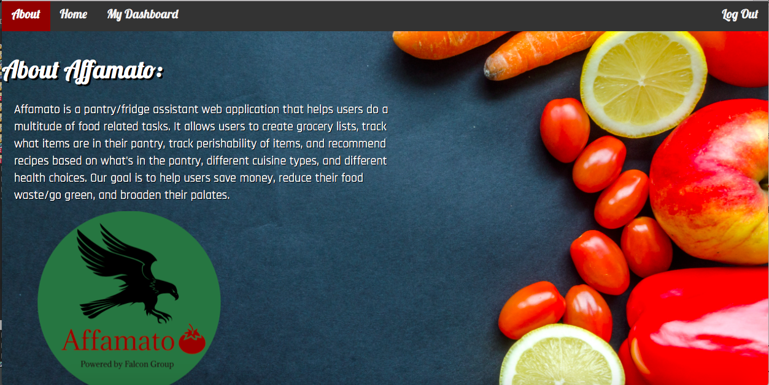

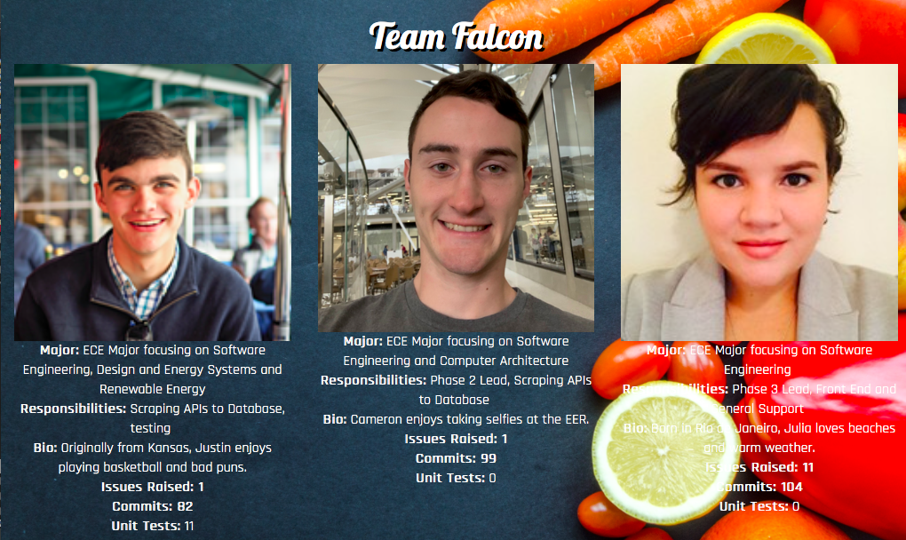

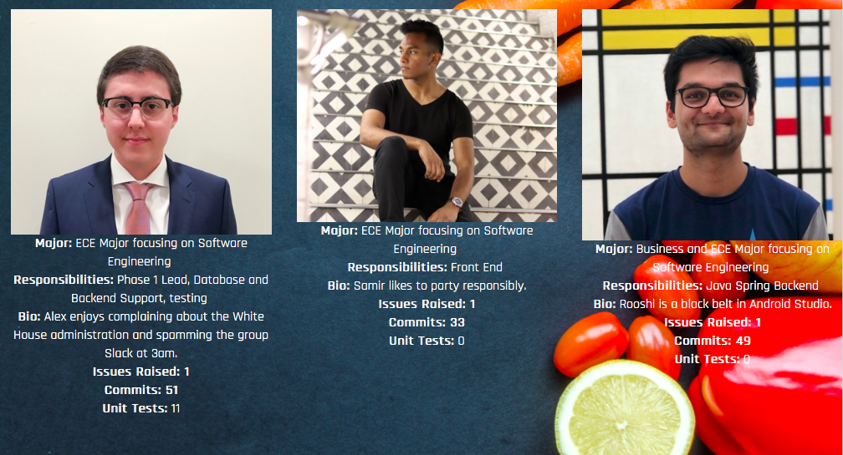

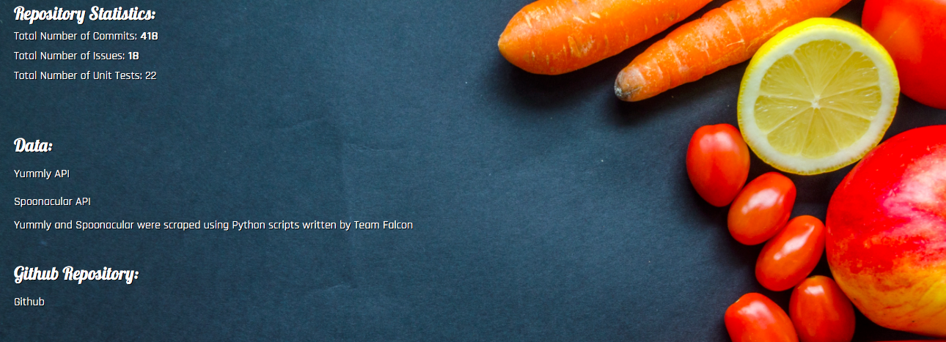

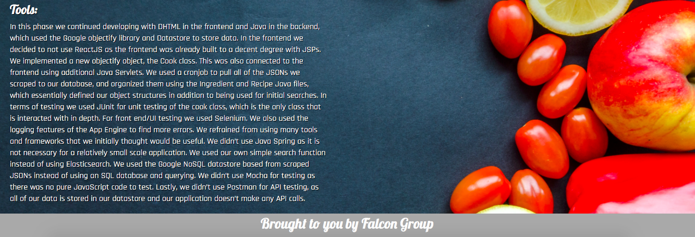

The about page has information on Affamato and Group Falcon, along with statistics from our Github repository, which are dynamically pulled from the API.

-Affamato Dashboard Page

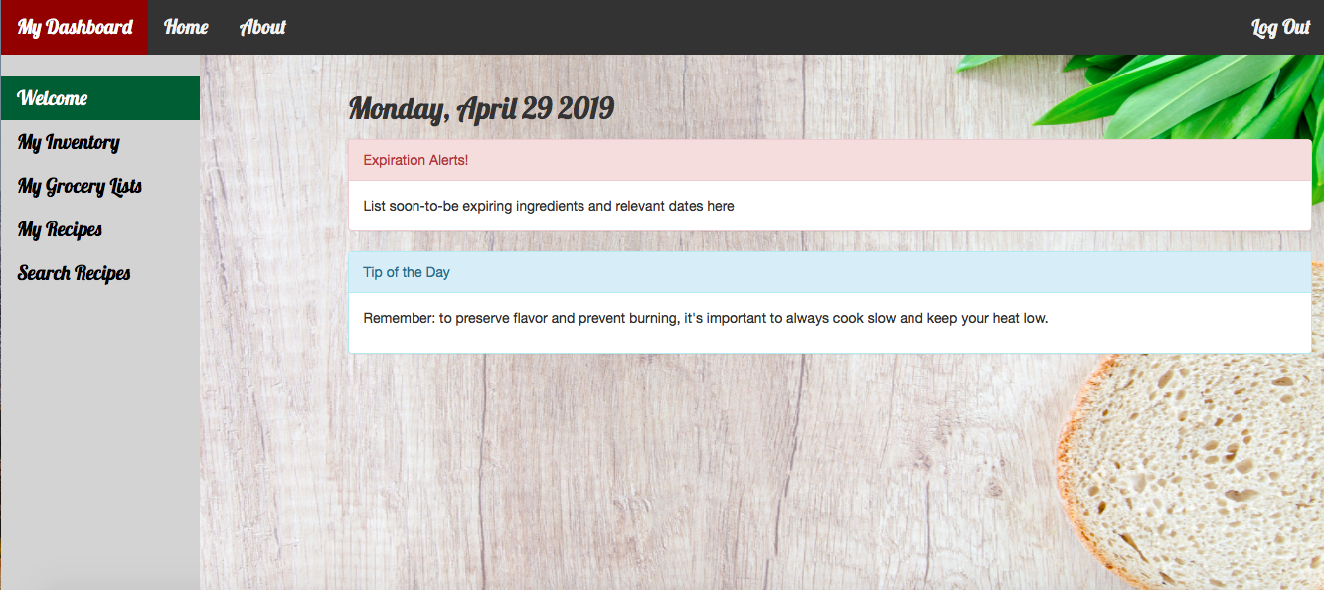

This page becomes available once a user is logged in. It displays a tip of the day, date, and is meant to list upcoming expiration dates, though that is not currently implemented. A user may navigate anywhere on the website from this page.

-Affamato My Inventory Page

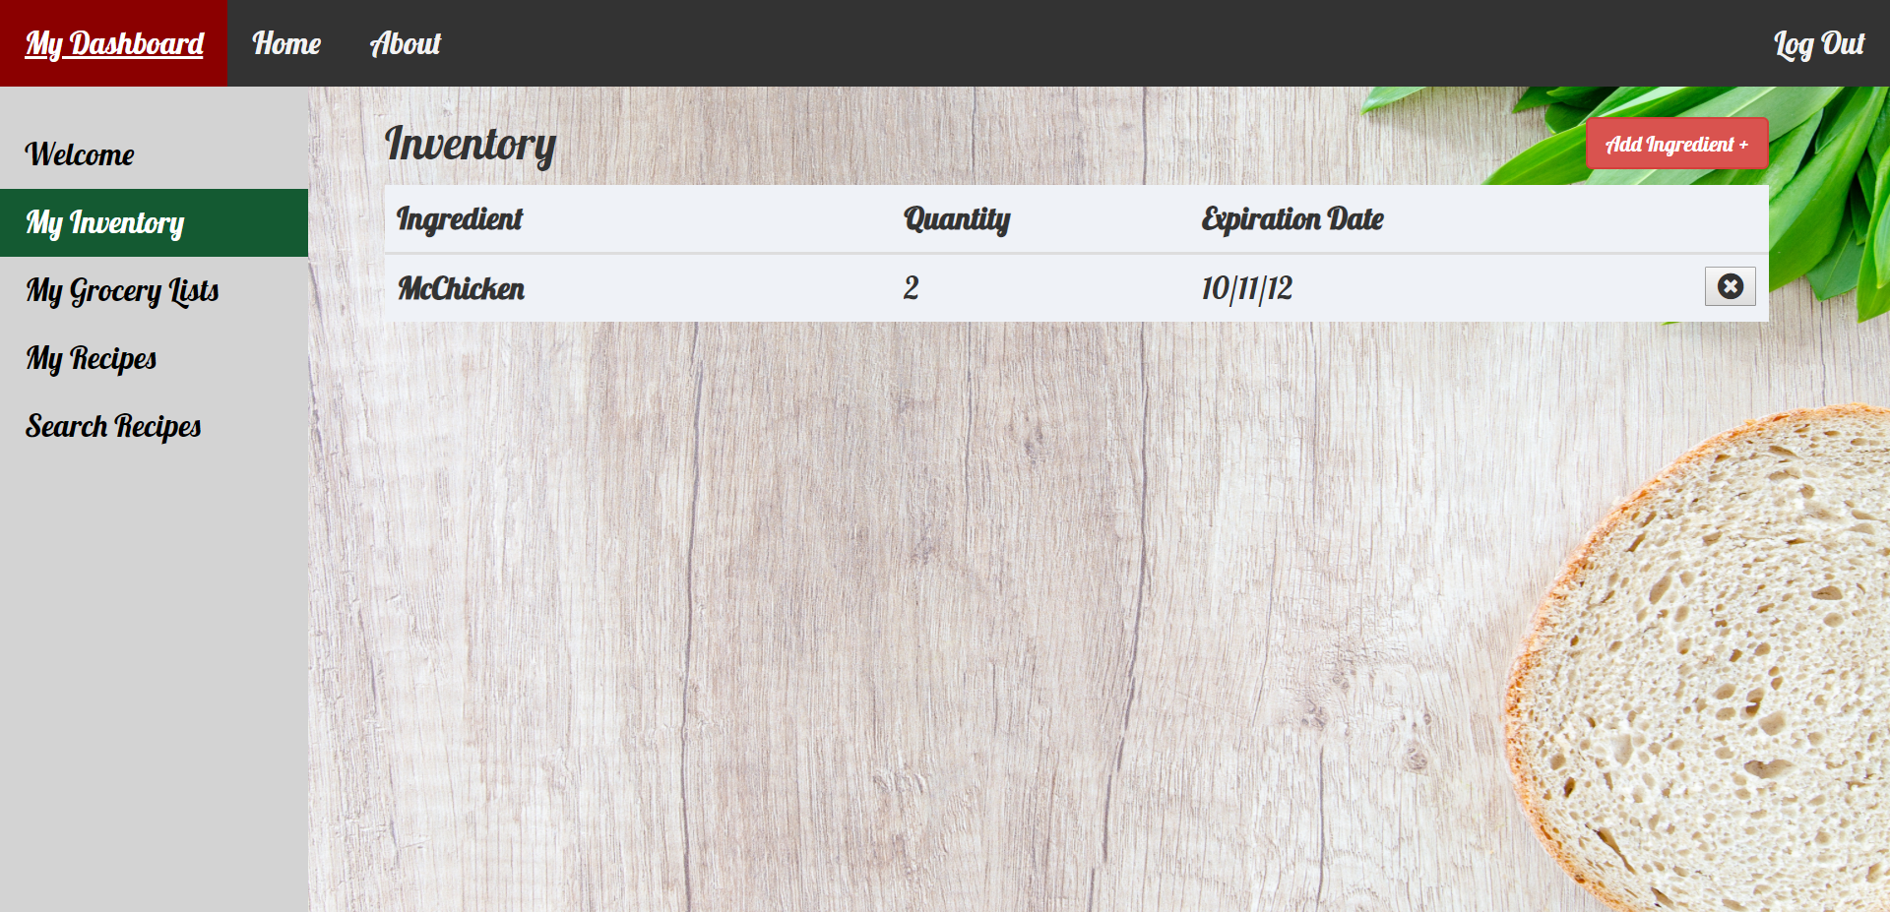

In the inventory page, the user is to be able to add and remove ingredients, quantities, and expiration dates that will be used for expiration alerts in the welcome dashboard page. The front-end of the page is fully functional, and the connection to the user’s datastore is still being implemented.

-Affamato Grocery Lists Page

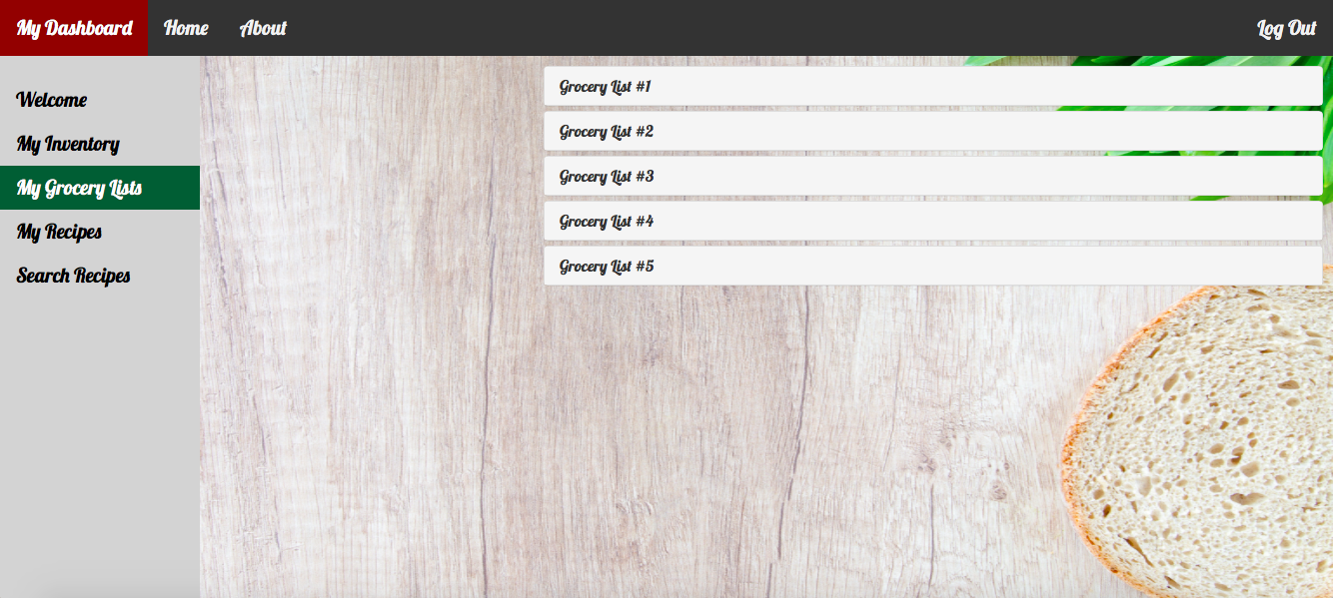

Each user gets 5 collapsible grocery lists. Users may add and remove anything they’d like to each grocery list. A user could even use one as a to-do list, as the items on the grocery list are totally user-inputted.

-Affamato My Recipes Page

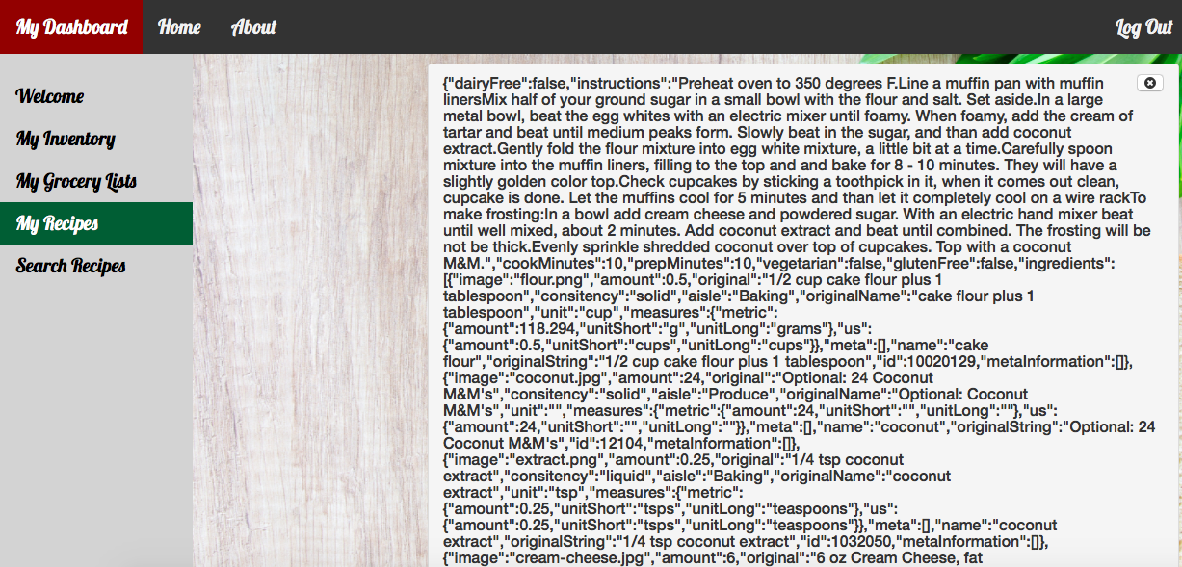

The recipes a user adds from the search recipes page get successfully added to the My Recipes page, but are currently rendering without collapsible capabilities. This will be addressed in phase 4.

-Affamato Recipes Search Page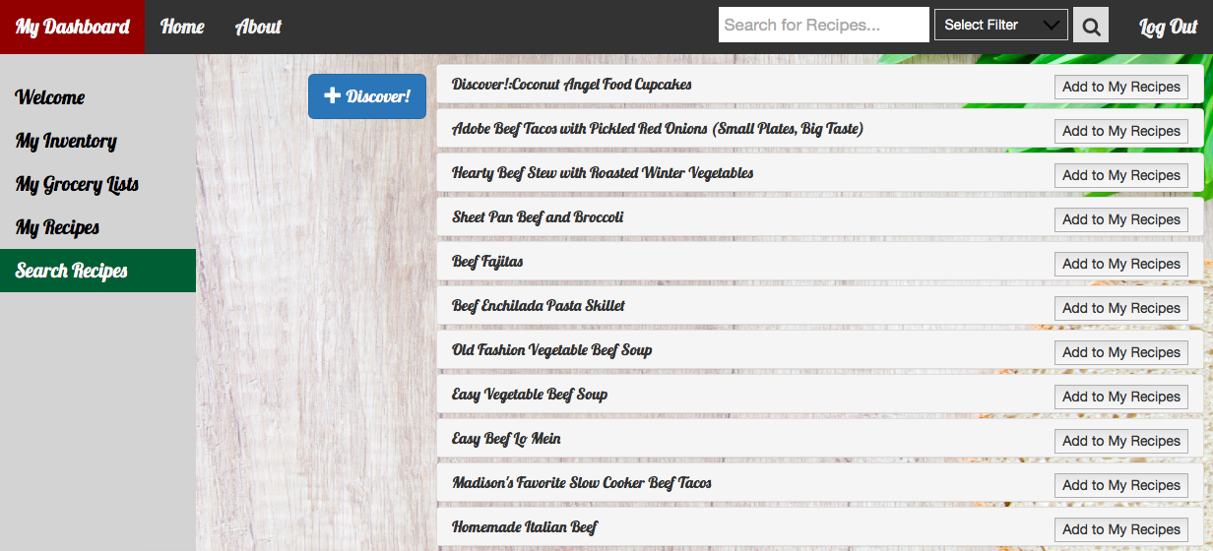

Users may search from the navigation bar and see the results come up on this page, with the option of adding any of the resulting recipes to their my recipes page. The Discover button returns a totally random recipe from the database and displays it at the top of the page, also with the option to add to my recipes page.

7. Tools, Software, Frameworks Used

In this phase we continued developing with DHTML in the frontend and Java in the backend, which used the Google objectify library and Datastore to store data. In the frontend we decided to not use ReactJS as the frontend was already built to a decent degree with JSPs. We implemented a new objectify object, the Cook class. This was also connected to the frontend using additional Java Servlets. We used a cronjob to pull all of the JSONs we scraped to our database, and organized them using the Ingredient and Recipe Java files, which essentially defined our object structures in addition to being used for initial searches. In terms of testing we used JUnit for unit testing of the cook class, which is the only class that is interacted with in depth. For front end/UI testing we used Selenium. We also used the logging features of the App Engine to find more errors.

We refrained from using many tools and frameworks that we initially thought would be useful. We didn’t use Java Spring as it is not necessary for a relatively small scale application. We used our own simple search function instead of using Elasticsearch. We used the Google NoSQL datastore based from scraped JSONs instead of using an SQL database and querying. We didn’t use Mocha for testing as there was no pure JavaScript code to test. Lastly, we didn’t use Postman for API testing, as all of our data is stored in our datastore and our application doesn’t make any API calls.

8. Testing

In phase 3 our unit tests were implemented with JUnit. As the Ingredient and Recipe classes are only used when making the initial search and getting a string with the relevant information, all of our unit tests were focused on the Cook class. Additionally, the Ingredient and Recipe classes do not change; they only serve as a framework for the database to draw from. Consequently, the Cook class was the most essential class to test, as the fields in the Cook class are changing often as the user updates their lists and search results.

For the RecipeList, tests were implemented focusing on the functionality of adding recipes to the list and removing recipes from the list. Very similar tests were implemented for the Pantry, testing the functionality of adding and removing ingredients. Similar tests for GroceryList were also implemented testing the functionality of adding and removing ingredients, also expanded because there are multiple grocery lists. These tests were created to ensure that the lists are functional in multiple scenarios as these lists change often but are seldom cleared.

Tests were also implemented for GrocerySearchResults, RecipeSearchResults, and PantrySearchResults. Tests for each set of search results test adding to the list of search results and, getting the results back from the cook class successfully. These tests were more simple, as these fields are essentially used for passing information from backend to frontend.

For the frontend, we used Selenium to build integration and interaction tests that helped verify our front end was working as needed. We were able to check the ability to log in or out from different pages and verify that it worked correctly. We also checked that button redirects to different pages worked correctly, and that data was updating when we submitted information into the different pages.

Lastly, we used the Logging functionality of the App Engine to find further issues with how our code was running. This, combined with visual inspection, allowed us to catch bigger issues and then quickly pinpoint why there was an error with our code.

9. Final Reflections

There was a lot that was hard about this project. There were two main issues that we think caused a lot of blockers for us. The first was a general lack of familiarity with a majority of the tools and languages we had to use. No one on our team knew DHTML or Javascript, no one had experience with developing websites, and there was minimal experience with the Cloud (And no experience with GCP specifically), etc. While we covered some of this material in class, the lack of depth or practice time that we got before being asked to essentially build a startup company wasn’t enough to really feel comfortable with what we were doing and to do it efficiently. We ran into lots of blockers where we didn’t know what to do, and while the answers were often trivial once we found them, our project would be completely derailed until we could find the answer. We don’t think these issues are particularly the class’s fault, we think there’s just a lot of material to cover in the class, and most of the things we needed to do the project weren’t what we went into depth on in class. There was a lot of self teaching done.

The second big issue was effectively a mistake on how we went about designing our project. We decided to do the backend and frontend completely independent of each other, and then connect everything together at the final stage. This was a huge error, as the backend team built a lot of stuff that wasn’t quite what the frontend needed/anticipated having to pull the information and update it. Then from the frontend, when they didn’t know how to interact with something from the backend, it was often because they didn’t know the ins and outs of the backend code. This lack of understanding from each side led to lots of delays in our ability to finish the project.

Furthermore building out the backend and frontend failed because it took too long to make the backend functional before we could attempt to connect the two. We spent a significant amount of time attempting to solve problems with the backend. These problems mainly involved updating the Cook class when searching. We attempted to use JSONArrays in the datastore for a while before realizing that it isn’t possible with Objectify - it wouldn’t update. Because of this, we also spent a significant amount of switching the cook class from using strings to using JSONArrays and back to strings. This took a significant amount of time as we had to update all of the methods in Cook multiple times.

On the frontend side of things, we also made a big mistake with our planning. None of us knew ReactJS or Bootstrap, but since we know that it’s kind of the industry standard for front end, we had one team member learn and build the entire front end themselves. This was obviously a lot of work, and while we had a framework to build off of, we realized we had no idea how to deploy it to GCP with the Java code we wrote for the backend, and then decided to go back to JSPs and Java Servlets with a DHTML front end.

As a result of the significant amount of time spent spinning our wheels we didn’t implement all of the functionality we hoped to. The main functionality that is missing is the ability use the inventory and expiring items to search for recipes. Additionally, users are unable to search for ingredients from our datastore and add them. Furthermore, users can not automatically add ingredients they don’t have from a recipe to their grocery list.

If we could do something differently, the main thing we would change would be to implement small pieces of the code completely on both the frontend and backend, and go from there. This would’ve let us make mistakes and learn from our issues at the beginning, and then be more adjusted to the problems we’d face at the end. Overall, we learned a lot from this project, and it was definitely both a challenge and fun to do! We all think this will be a great project and team experience to talk about in interviews, and we believe what we learned will benefit us in future endeavors.